Implementation Plan - Saturday

1. Shutdown WAS servers in Cloud – 8PM (Joe Jia)

|  |  |
| --- | --- |
| 172.30.29.243 | catr11bq12013 |
| 172.30.29.244 | catr11bq12014 |

1. Update Certificates on Datapower (BPM-PROD) – (Kevin Paterson)

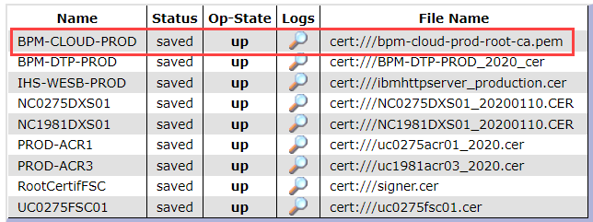

Select: nc0275was-root-ca-prod_2020

FDR - PROD

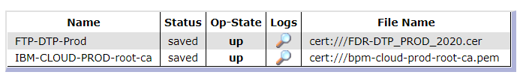

Select: nc0275was-root-ca-prod_2020

Implementation Plan – Sunday

1. Upon verification of Database migration, start WAS servers (Node 1 only)

|  |  |
| --- | --- |
| NC0275WAS01 | 10.155.2.167 |

1. Update DNS – Network team

update DNS to point to F5 VIP 10.155.33.75 for un1c.banquelaurentienne.ca

update DNS to point 10.155.14.93 to un1c-pc.banquelaurentienne.ca

1. Perform Ping check on un1c.banquelaurentienne.ca – confirm pointing to above IP.
2. Update ProcessAdmin settings https://un1c.banquelaurentienne.ca/ProcessAdmin

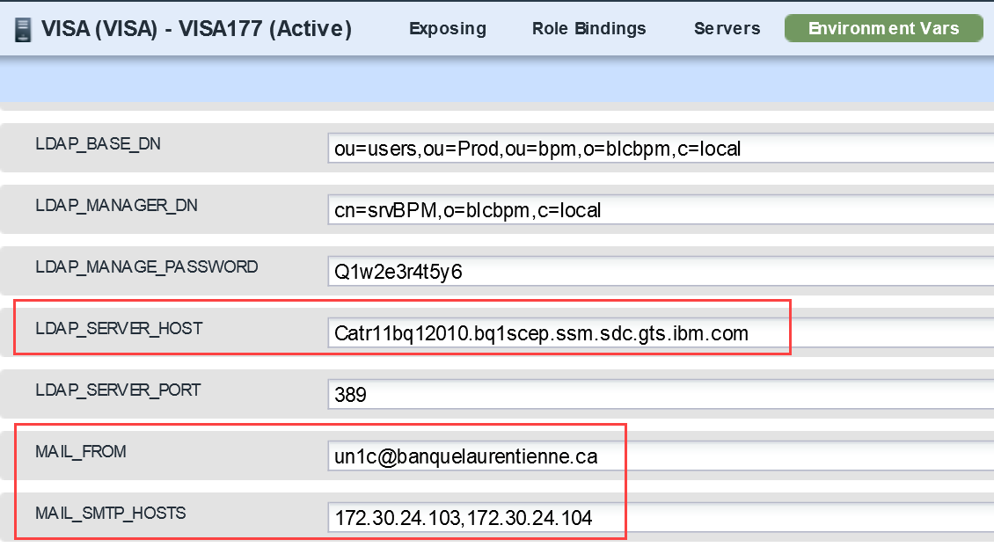

LDAP_SERVER_HOST: nc0275sql05.blc.banquelaurentienne.ca

MAIL_SMTP_HOSTS: 10.151.48.113,10.151.48.114

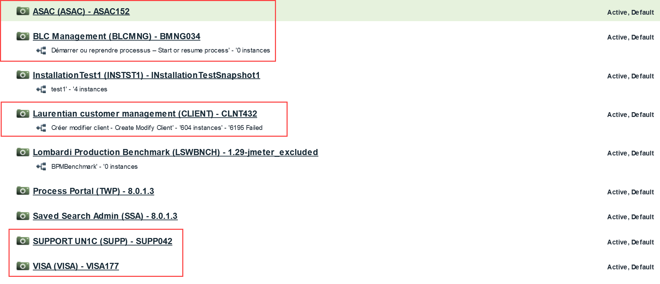

Update LDAP

